**Illinois Institute of Technology**

**CS 587 – Software Project Management**

**Assignment-1 Report**

**Name:** Shiva Sankar Modala

**HAWK ID:** A20517528

4) What is the earliest finish date for this project if it is scheduled to start on 9/12/22?

Ans) As per the resources I assigned, the earliest finish date of the project is

Wednesday 25-01-2023 i.e, January 25, 2023.

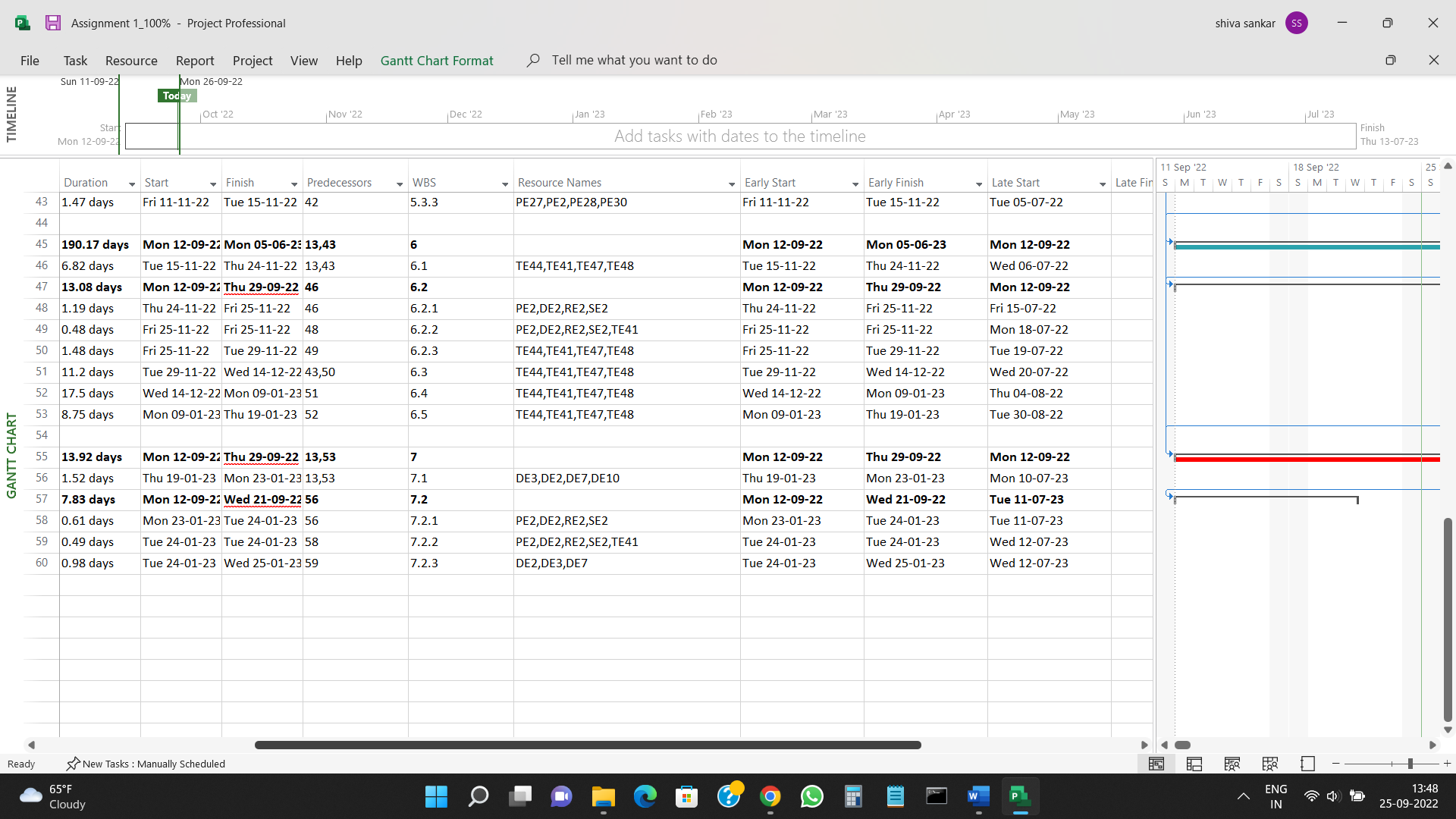

5) If you are not allowed to use more than 30% of the resources available at any point of time for this project, what is the earliest finish date for this project if it is scheduled to start on 9/12/22?

Ans) If you are not allowed to use more than 30% of the resources available at any point of time for this project, the earliest finish date of the project is

Friday 08-12-2023 i.e, December 08, 2023.

